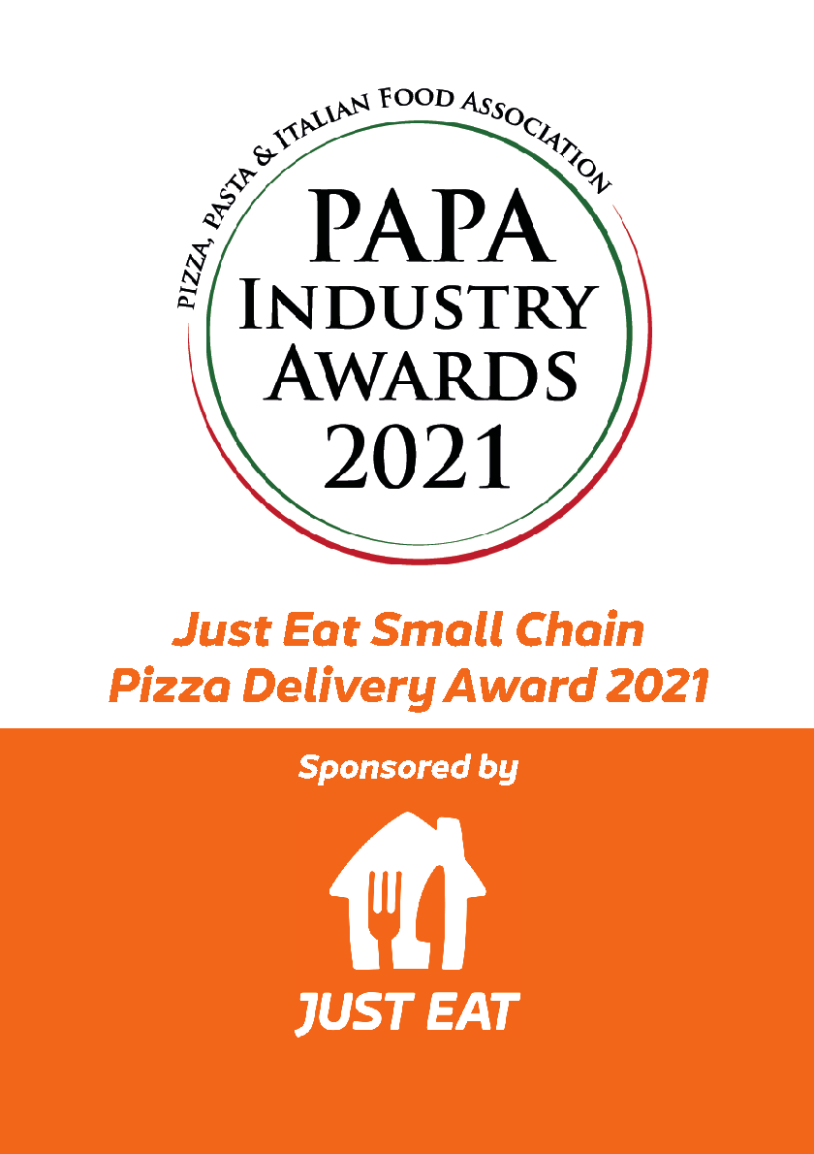
The award...
This award aims to give recognition to the small chains (businesses with between five to 20 stores) in the pizza delivery sector.

Sound like you?
To enter, you’ll need to be a small chain delivery operator with a food hygiene rating of 5. And that’s it! Make sure you’ve filled out all details below and return them no later than 12th August 2021.

The prize
The award winner will receive free Just Eat sign-up, plus once online, a co-branded package. If you’re already with Just Eat, you’ll be refunded your initial sign-up fee, and will also receive the co-branded package.

Who are you?

We’ve made the entry process as easy as pizza pie, so just fill out the blanks below and email it to the address below.

Business name
………………………

Owner’s name
…………………….
No of stores
………………………

Mobile number
……………………….

Owner’s email address

……………………………………………………………………..

Business Address

……………………………………………………………………..

1)Tell us why you think your business deserves this award...

This bit is really important to our judges so make sure you fill it in!

Please give us a list of the sites you operate from, including postcode...
If you are shortlisted, the judges will conduct a ‘mystery shopper’ visit to one of your stores. If there’s a particular restaurant you’d prefer the judges to visit, please let us know.

Send us a couple of Photographs
Please attach an external picture of your restaurant together with one of the kitchen/preparation area. Make sure they’re as clear as they can be, and in colour.

Please email your entry to caron@jandmgroup.co.uk with the subject line, PAPA Entry Form. Please call 01291 636 346 for any further information.

The closing date for applications is 12th August 2021

