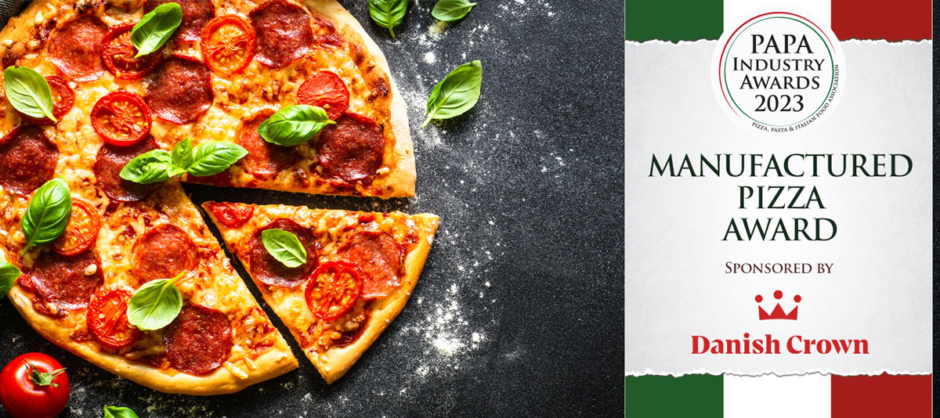

Award Qualifying Period
1st September 2022 to 31st August 2023

Closing Date
23:59hrs - Wednesday 9th August 2023
Please complete the required information below and the full award details can be found on the website – www.papaindustryawards.co.uk

Contact Name:
Position:
Business Name:
Address:
Postcode:
Business Tel:
Mobile:
Contact E-Mail:
Launch Date:
Retail Price:

Please provide your written submission here with detailed information to support why your pizza product deserves to win the award
Other supporting material may be sent together with your entry

