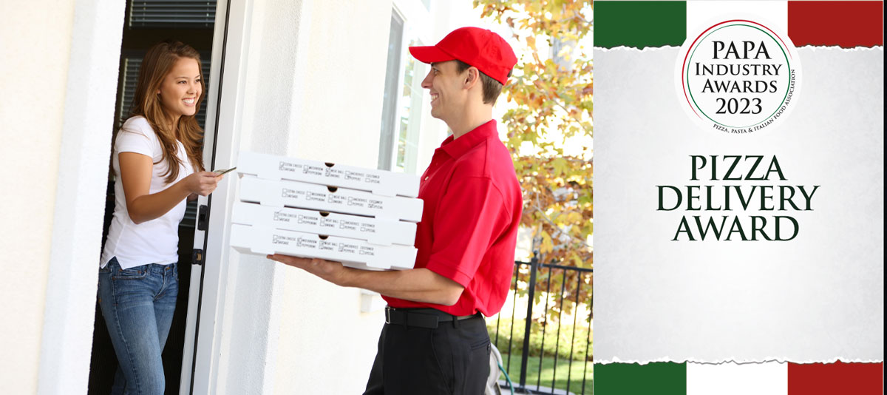

The award...

This award aims to give recognition to the shining stars of the pizza delivery market.

The awards will be presented in three categories: Major Chain (101+ stores), Small Chain (up to 100) and the Independents with up to 5 stores. stores. All those considered for the award must have a food hygiene rating of 5.

**Award Qualifying Period**

1st September 2022 to 31st August 2023

**Closing Date**

23:59 hrs - Wednesday 9th August 2023

Please complete the required information below and the full award details can be found on the website – www.papaindustryawards.co.uk

**Contact Name:**

**Position:**

**Business Name:**

**No of UK Delivery Stores**

**Address:**

**Postcode:**

**Business Tel:**

**Mobile:**

**Contact E-Mail:**

|  |
| --- |
| Please provide your written submission here and why your company deserves to win the award  Other supporting material may be sent together with your entry |
|  |